Last updated: December 17, 2013

American Art’s Database Structure for Permanent Collection Objects on Web
The Smithsonian American Art Museum uses a SQL 2008 database, called tmsweb, which is a nightly export (view) from the permanent collections database (TMS). The tmsweb database is then used by coldfusion and SQL to display our collection on the web.
Webserver Specs:
Windows Server 2008 Enterprise Edition
IIS7.5
Web servers are : Dell R710 with 48 GB Memory (RAM) in which OCIO installs 64 Bit Windows 2008 R2 with IIS 7.5.

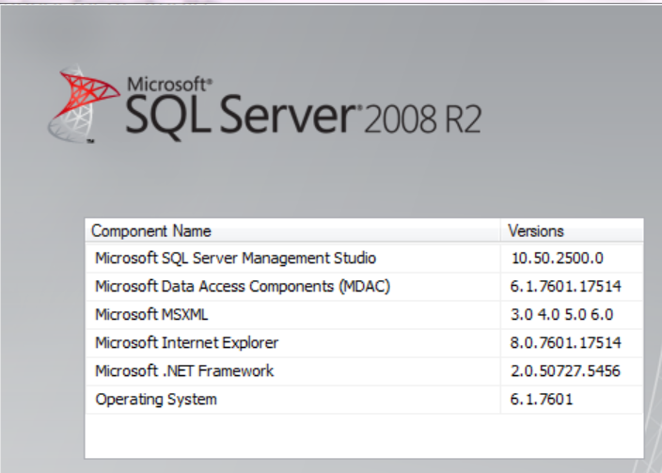

SQL tables for Search Artworks and Artists
Database: tmsweb
Tables:

WebArtistBio - Artist biographies
Fields:
Constituent ID – Constituent ID from the WebConstituent Table. It is a unique identifier for every artist.
BioDsp – Formatted content that is displayed as the artist biography on our website. The Citations are included as part of this text at the end.
PrimaryBio – Artist Biography intended to be ordered first on the web page if there are multiple biographies. PrimaryBio=Primary will display first. PrimaryBio=NULL if only one biography or display secondarily if more than one biography.

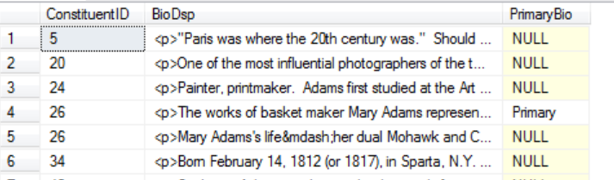
NEW: WebArtistBioImages - All artist images displayed on artist biography pages.
Fields:
ConstituentID: Unique identifier for every artist
Filename: Filename of artist image.
If MediaView=Permanent collection, the image location is http://americanart.si.edu/images/first 4 digits of filename/Filename
If MediaView=Juley, artist image location is http://americanart.si.edu/images/JuleyBio/FileName
If MediaView=Luce, artist image location is http://americanart.si.edu/images/luce/artists/FileName
PrimaryDisplay: PrimaryDisplay=1 Image will display first if more than one image
PublicCaption=Caption text to display with image
ObjectNumber=Accession Number if artist image is a permanent collection image
ObjectID=ObjectID if artist image is a permanent collection image

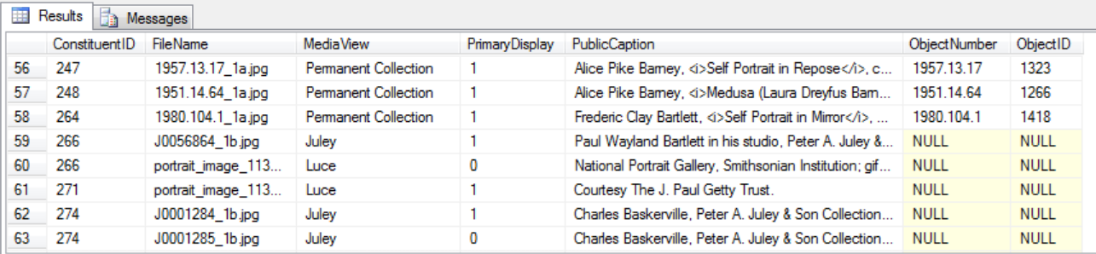

ObjCurLocView: - Locations of objects if on view
Web uses: ObjectID, Cursite, Description
If it is on view CurSite will have an @ in it.
Display site with Description
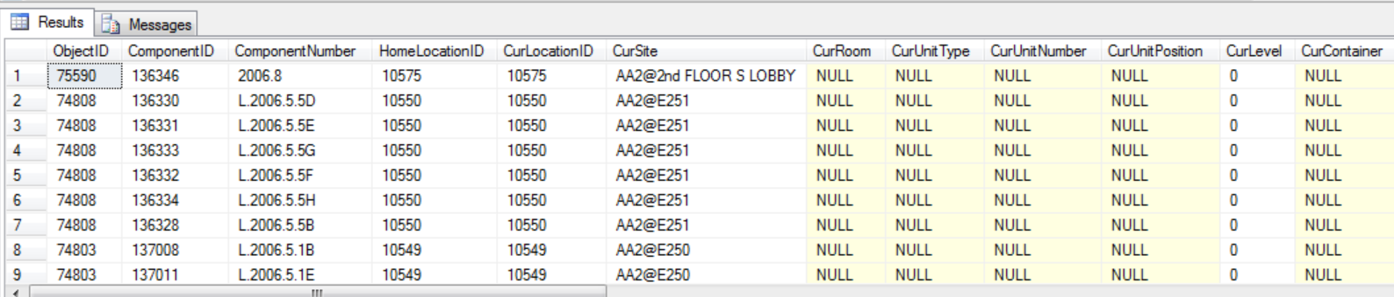
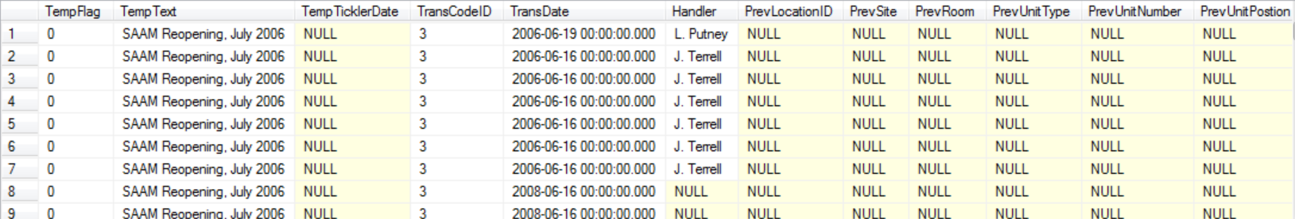

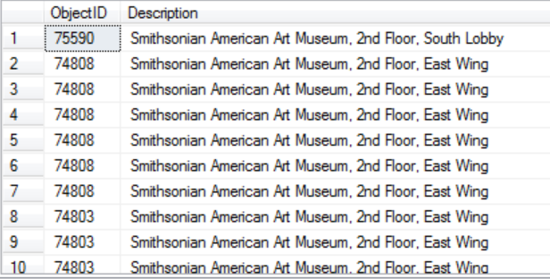

TermsWithPathView - Table used for all other keywords (besides webobjcaption- classification and subclassification)
Fields: ThesXrefType, TableID, ID (same as ObjectID in other tables), PathTerm

Select Statement:
SELECT ThesXrefType, TableID, ID, PathTerm
FROM cbev2.TermsWithPathView
WHERE (ThesXrefType = 'Crafts') OR
(ThesXrefType = 'Medium') OR
(ThesXrefType = 'Subject Specific') OR
(ThesXrefType = 'Process') OR
(ThesXrefType = 'Patronage') OR
(ThesXrefType = 'Support') OR
(ThesXrefType = 'Folk Art')

PathTerm examples:
Authorities\Attributes\Objects\Subject Specific\Architecture\education\Princeton University Authorities\Attributes\Objects\Subject Specific\Waterscape\inlet Authorities\Attributes\Objects\Subject Specific\Animal\bird\owl
Below is an example of a single TermsWithPathView record for ID=16998 which corresponds to the ObjectNumber 1988.88.2, Tina Turner
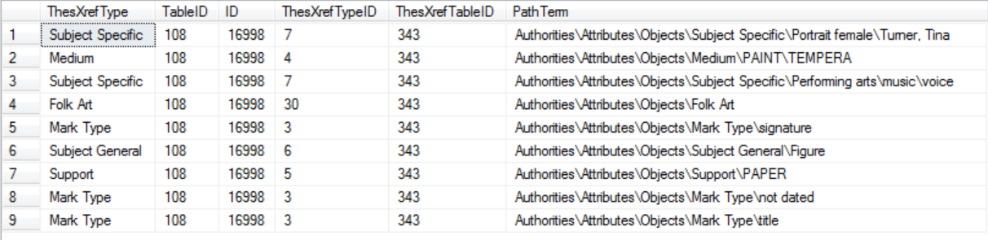
The resulting page on our website for 1988.88.2 would have the keywords look like this:
Keywords:
painting
folk art
paint - tempera
Performing arts - music - voice
Portrait female - Turner, Tina
paper

Excluded from report are Subject General and Mark Type for ThesXRef types. The PathTerm is just a long list separated by a back slash. Our search changes these backslashes into dashes and just searches for any word in this field.
WebConAltNames:
These are all “also known as” names for many of our artists in the WebConstituents File. If any AKA’s exist for artists, they are listed in the artist bios pages under “Also known as”. Example: http://americanart.si.edu/collections/search/artist/?id=15

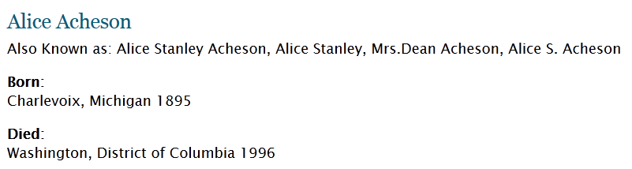

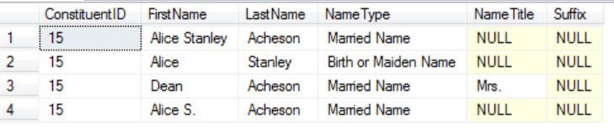
Fields: ConstituentID – A unique ID for every artists. This refers to ConstitutentID in WebConstitutent Table.
FirstName – First name of artist’s name (AKA)
LastName- Last Name of Artist (AKA)
NameType – can either be
Pseudonym
Later Name
former name
Preferred with Accents
Married Name
Conferred Name
Birth or Maiden Name
Variant Name
NEA application name

All names are just listed as “also known as” without reference to the name type.

NameTitle: Title coming before an artist name. See below for all types
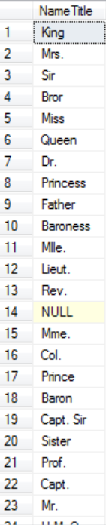
Suffix – Come after the artist name and are all listed below.
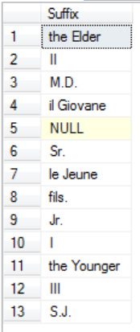

Note: Some entries exist for artists that have been deaccessioned so they will be present in this table but filtered out of the WebConstituent Table
WebCondates: Life and Death Dates for Artists
Fields: of all fields below we only use the ones in bold (DateDescription and DateBegSearch)
ConDateID – unique id for every date
ConstituentID – unique id for every artists (in WebConstituent table)
DateDescription: Our website only uses these types: Birth Date, Death Date
DateBegSearch: Website uses both year of birth or year of death. All other dates are ignored.
DateEndSearch – don’t use
Remarks - don’t use
LoginID don’t use
EnteredDate don’t use
SysTimeStamp don’t use
DayBegSearch - Day Date. We only use in artist birthdays
DayEndSearch don’t use
MonthBegSearch – Month date. We only use in artist birthdays.
MonthEndSearch don’t use

Again, using Charles Bird King from other example:

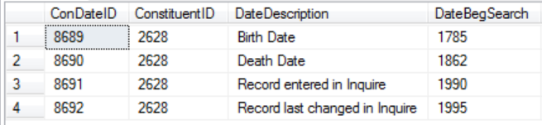

WebConGeography: Geographical data for all artists. This displays on our Artist Bios pages as Born, Died and Active in. Example:

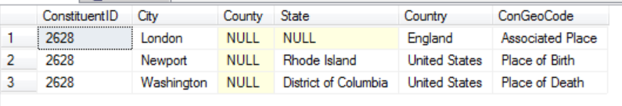
Will display on Artist Bios page:
http://americanart.si.edu/collections/search/artist/?id=2628
as:
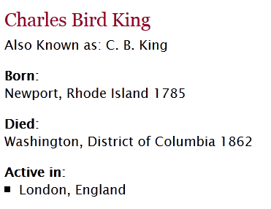

Fields:
ConstituentID – unique id for every artists (in WebConstituents table)
City – city of activity
County – county of activity
State – state of activity
ConGeoCode: There are types
- Place of Birth
- Place of Death
- Associated Place - associated place is listed if we feel they were active there as artists
- Last Known Residence

WebConstituents –
For Search Artworks, fields used: code=Provisional, Candidate, Verified (These three codes are applied to constituents who are artists for the permanent collection (as opposed to donors, etc.). If we don't select these codes only we will end up with other types of constituents showing up on the web, like SAAM staff members, donors, etc. ) **
Both the Webmakers table and the Webconstituents table have the artists names but the Webmakers table contains NEA artists that we do not link to for copyright reasons and none of these artists link to any object anyway. These artists have (NEA) in their displayname – example: BRIAN CONLEY (NEA)
So: It would be better to use the WebConstituents file for artists names that we use. The Webmakers table is needed as a link between those artists we do display and their works.

**In our database there are only these 3 types (provisional, candidate and verified) so should not need to check for them.
For search artists this file is used for: ConstituentID, DisplayName
Unused field: Use Begin and End for internal tms searching purposes. If no date, tms uses Begin=Artist BirthDate and End=either Artist Death date or the year of acquisition whichever is less
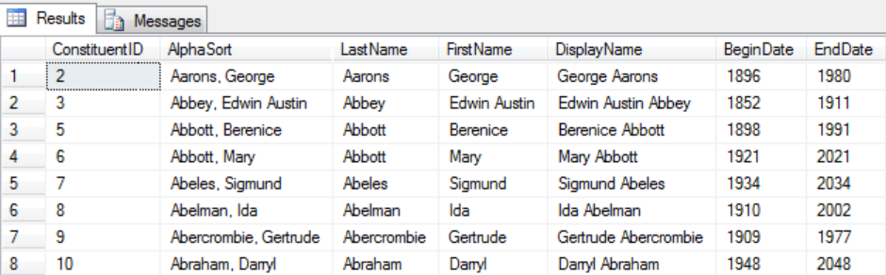
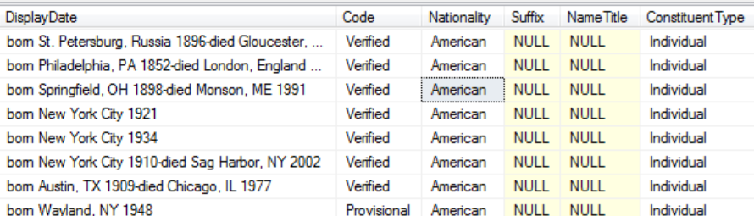
ConstituentType: 2 types - individual or institution
Note: BeginDate and EndDate are just general search ranges for tms users. Ignore for web display purposes. Often it will be birth and death date but it can span many years if unsure of the date.
Nationality: We don’t use that field on the web – what we do for foreign artists is include it in the display bio field as part of the entire line of text:
http://www.americanart.si.edu/collections/search/artwork/results/index.cfm?rows=10&q=&page=1&start=0&fq=name:%22Altamirano%2C%20Arturo%20Pacheco%22
So for this artist (who is Chilean), if you look at the link above the display bio is “Chilean, born Chillán, Chile 1905-died Santiago, Chile 1978.” But the nationality would be repeated in the nationality field in TMS as “Chilean.”
WebObjCaption - Table used for Tombstone data
Fields: ObjectID ,objectnumber, Title, dated, Medium, Creditline (who donated to object to the museum or if we purchased it – i.e. a credit to the person who helped us acquire the work), Dimensions, Classification, SubClassification, CreditLineRepro (used to display copyright @1961 Christo for example. This is if an artwork is under copyright of an artist. An artist could still own copyright of work and image even though we have the work)
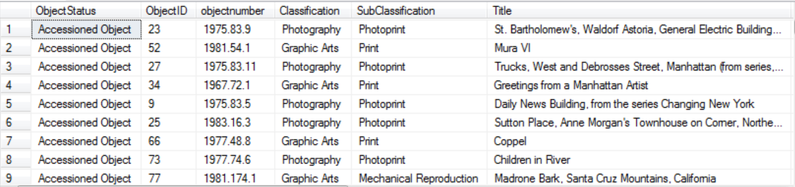
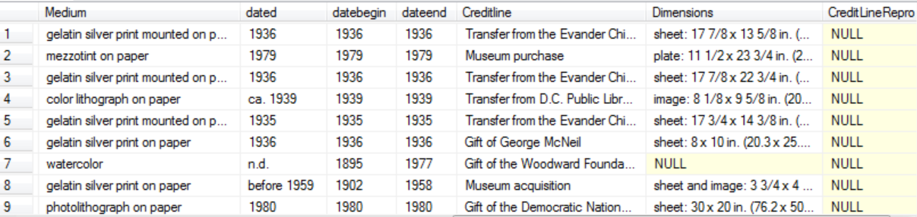
User dated only. Datebegin and dateend are for tms searching purposes. They can be the same as dated, but not always, as is the case of n.d. (no date)
The 2 fields Classification and Subclassification fields used for part of keywords
Keywords:
Classification= Drawing, Sculpture, Other, Collage, Graphic Arts, Decorative Arts, Media Arts, Silhouette, not assigned, Photography, Painting
Subclassification=NULL, Print, Photoprint, Furniture, Assemblage, etc
Examples:
Classification=Decorative Arts Subclassification=Fiber
Classification=Decorative Arts Subclassification=Jewelry
Classification=Decorative Arts Subclassification= Ceramics
Classification=Decorative Arts Subclassification=Glass
Classification=Decorative Arts Subclassification=Furniture
Classification=Drawing Subclassification=Miniature
Classification=Graphic Arts Subclassification= Book
Classification=Graphic Arts Subclassification= Block/plate/stencil
Classification=Graphic Arts Subclassification= Mechanical Reproduction
Classification=Graphic Arts Subclassification= Print
Classification=Other Subclassification= Archival Material
Classification=Painting Subclassification=Miniature
Classification=Painting Subclassification=Mixed Media
Classification=Photography Subclassification=Photoprint
Classification=Photography Subclassification= Photomechanical Reproduction
Classification=Photography Subclassification= Phototransparency
Classification=Sculpture Subclassification= Assemblage
Classification=Sculpture Subclassification=Relief
Classification=Sculpture Subclassification=Kinetic
Classification=Sculpture Subclassification=Medal
Classification=Sculpture Subclassification=Medal-Sample
Classification=Sculpture Subclassification=Maquette
Classification=Sculpture Subclassification=Miniature

WebObjDescription - Descriptive text about artwork objects.
ObjectNumber=Accession Number
TextType = Exhibition Label, Gallery Label, Research Notes, New Acquisition Label, Luce Center Label
Description= Text displayed with artwork

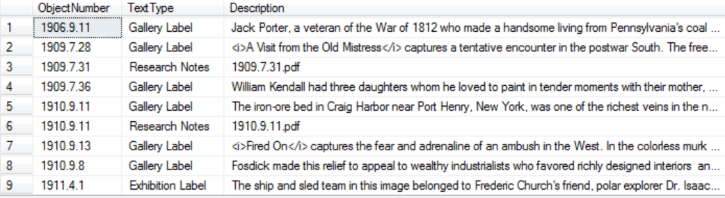
WebObjectImages - Table used to display images on web.
Fields: Rank, FileName, Display, ObjRightsType
Rank: Object records that have images displaying on the web must have a Rank=1. (Rank=2 is used for digital ID shots)
Filename is actual name of image file. For example: ObjectNumber 1999.21.3 has a filename =1999.21.1-11_1a.jpg. Loans are identified by TL. Or L. in front of the accession number.
PrimaryDiplay – Display if PrimaryDisplay=1 (Primary display of 1 is the view we show on the web. Additional views may be present however that are high quality images and can be displayed if the option is available. Primary display is also used for recto/verso)
ObjRightsType = If this field = Restricted (See File) then must block from web display. All other entries can be displayed.
Summary: Display images if (Rank=1 and PrimaryDisplay=1 and (ObjRightsType is not Restricted (see File))

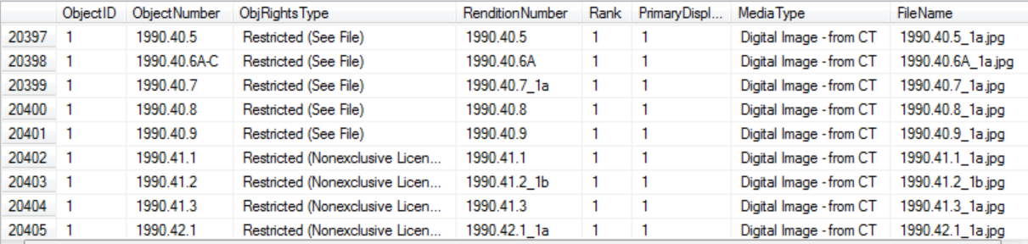
Resizing Images
Resizing images on the fly can be done through IDS with the format using accession number and the parameter, “max”
The image directory is always the first 4 digits of the accession number – i.e. 1981.76 would be located in the directory 1981.
So the image for the accession number (objectnumber), 1981.76 would be1981.76_1a.jpg and would be found in the location: http://americanart.si.edu/images/1981/1981.76_1a.jpg
To resize use this format:example: http://ids.si.edu/ids/deliveryService?id=http://americanart.si.edu/images/1981/1981.76_1a.jpg&max=400
example: <img width="150px" src="http://ids.si.edu/ids/deliveryService?id=http://americanart.si.edu/images/1981/1981.76_1a.jpg&max=400">

Webmakers - Table used to link artists (or institutions) to their object records (links ConstituentID with ObjectID in WebObjCaption).
Both the Webmakers table and the Webconstituents table have the artists names but the Webmakers table contains NEA artists that we do not link to for copyright reasons and none of these artists link to any object anyway. These artists have (NEA) in their displayname – example: BRIAN CONLEY (NEA)
So: It would be better to use the WebConstituents file for artists names that we do use. The Webmakers table is needed as a link between those artists we do display and their works.
Fields: ObjectID, ConstituentID, Maker, DisplayName, LastName, FirstName, DisplayOrder, Prefix ,Suffix ,Role
Prefix: Example: Copy After
Suffix: Example: And Others (only the detailed records are using this – our SQL tables, not the Edan thumbnail results. Probably need to stop using…)
Role: Examples: Printer, Publisher, Manufacture, Author, Founder etc. (the role in an object)
DisplayOrder= order to display all artists in an artwork. 1=first, (usually artist) 2=second (could author ) etc
Note: Middlename is part of the first name

Ignore alphasort. This just designates a particular order for tms users.

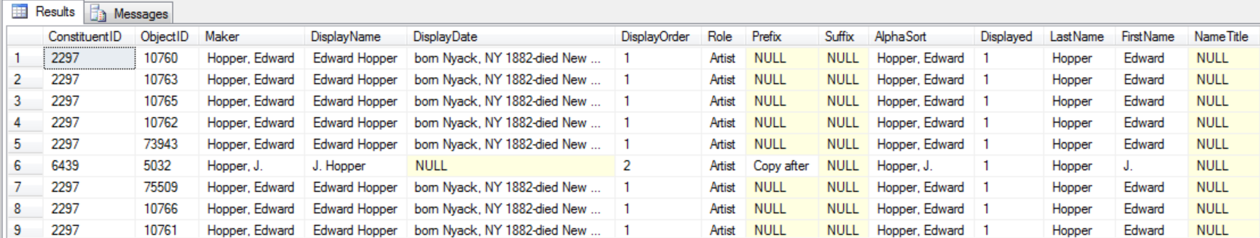
Below shows Suffix. Only 50 records and they are all Thayer.
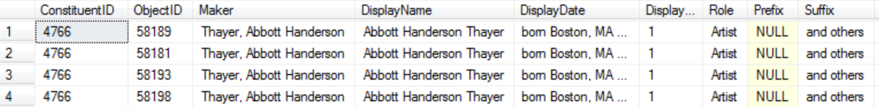
Old tables that are no longer used:
NO LONGER USED: ArtistBioJuley
(New table: WebArtistBioImages)
Juley images for SAAM constituents.
Fields: Title, ArtistName, JuleyNum as ObjectID Date as Date, CreditLine, PrimaryImage, Medium, Dimensions, DisplayOrder, Notes as ObjRightsType
NO LONGER USED: ArtistBioSAAMImages:
(New table: WebArtistBioImages)

All PCDB images for Artist bios AccessionNo AS imageID PrimaryImage
NO LONGER USED: Citations.
(Now included as part of the text in WebArtistBio and WebObjDescription)

Table for all citations AuthorDisplay TitleDisplay PublicationInfo
Code: Not used
Use TitleDisplay, not Title. Title is raw unformatted text that is not updated.
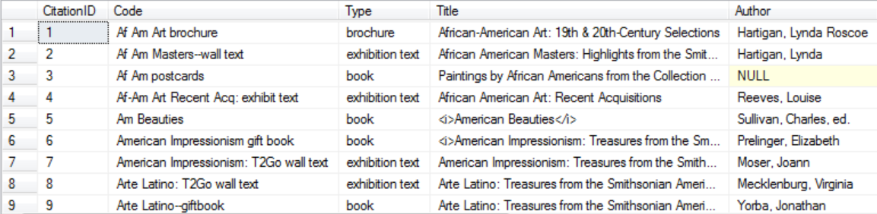
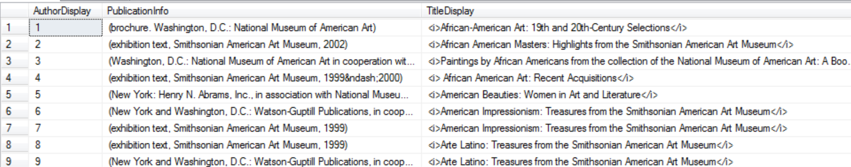

NO LONGER USED: Luce Labels:
Now use WebObjDescription
These come from a separate database from tmsweb and is called:
Database: SAAM_sitebots_v1
Table: SAAM_sitebots.collection_objects
Fields used: description_web, quote_body_1, accession_number,sb_key
Records are selected from this table when objects have been made live i.e. sb_live = 'live'
